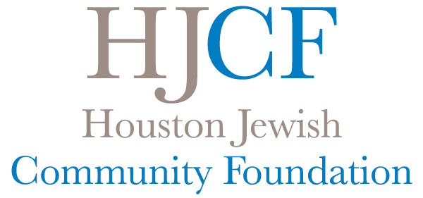

FREQUENTLY ASKED QUESTIONS ABOUT
OUR DONOR-ADVISED FUNDS

How many Donor-Advised Funds are there at the Houston Jewish Community Foundation?
There are more than 350 Donor-Advised Funds at the Foundation.

Are there any limitations on the frequency or size of grants from Donor-Advised Funds?
There is no limitation on the number of grants that can be made from an individual Donor-Advised Fund. Grants are recommended starting at $100 or more.

What types of causes can be supported through a Donor-Advised Fund?
An extremely wide range of charitable organizations can be supported through a Donor-Advised Fund. Grants may only be made to organizations that have received a 501(c)(3) charitable status from the IRS and have a public charity status that fits the guidelines enacted on August 17, 2006. Approximately 40% of the grants made each year are to non-Jewish charities.

How often are grants made from Donor-Advised Funds, and what record is provided regarding these grants?
Grants are processed weekly. Grant recommendations received by staff before 5:00 p.m. on Monday via Donor Central (online portal), via email, or by contacting a HJCF team member will be processed and mailed to the charity that week. Fundholders receive a quarterly fund statement recording all activity within the fund, including a list of all gifts to and grants from the fund.

Are there any requirements to make grants from Donor-Advised Funds to the Federation’s Annual Campaign or to any other cause?
Fundholders are encouraged to support the Federation’s Annual Campaign. However, there is no requirement that grants be made to support this or any other charitable cause.

Is there any requirement that a certain amount or a certain percentage of a Donor-Advised Fund be distributed to charitable causes each year?
There is no requirement that any amount or any percentage be distributed to charity in a given year (in contrast to Private Foundations which are required to allocate 5% annually). However, many of the Foundation’s Donor-Advised Funds do allocate more than 5% of their value each year.

What distributions may not be made from a Donor-Advised Fund?
Distributions may not be made to charitable organizations when goods or services of any kind are received in exchange for that grant. The 2006 Pension Protection Act, passed August 17, 2006, prohibits the receipt of benefits by a donor, advisor or related party to a donor advised fund (i.e., a grant cannot be made if a fundholder will be attending a fundraising dinner, for tuition or for membership dues); therefore, as of December 2, 2006, we stopped accepting bifurcated donations. Please note that you may recommend a grant to annually support your synagogue.

What is the minimum amount to open a Donor-Advised Fund at the Foundation?
The Board of Trustees of the Foundation wishes to make Donor-Advised Funds as accessible to the public as possible. The minimum gift required to establish a Donor-Advised Fund is just $2,500. The minimum gift amount to establish a donor-advised fund with third-party investment services is determined on a case-by-case basis.

What are the administrative fees associated with a Donor-Advised Fund?

An administrative fee of 1% per annum is assessed on the first $500,000 in assets in a Donor-Advised Fund. A reduced administrative fee is charged on assets above $500,000. ( 0.75% for assets $500k to $1M, 0.50% $1M to $2.5M, 0.25% $2.5M to $15M, and 0.15% for assets $15M+) A minimum administrative fee of $200 per year applies to most funds.

May others contribute to a Donor-Advised Fund?
Anyone may contribute to a Donor-Advised Fund. Many fundholders have requested that, in lieu of gifts, contributions be made to their Donor-Advised Fund in honor of their birthdays, anniversaries, etc. Acknowledgments are sent for all gifts made to the Foundation.

How can fundholders involve others (e.g., children and grandchildren) with their donor-advised fund?
Fundholders may designate others to be advisors or successor advisors of their fund. A Donor-Advised Fund can be a wonderful way to involve children and grandchildren in the family’s philanthropy. Foundation staff is available to visit with fundholders to discuss various approaches that may be appropriate for their situation. Many fundholders that have children and/or grandchildren have established a donor-advised fund to honor a birthday, graduation, or other life cycle event as a creative gift to encourage philanthropy.

What happens when a fundholder passes away?
The disposition of a Donor-Advised Fund upon the death or incapacity of a fundholder depends upon the recommendations received by the Foundation from the fundholder. A fundholder can recommend that the balance in a Donor-Advised Fund be divided among a variety of charities, or that a successor advisor (such as children or grandchildren) inherit the privilege of making recommendations from that Donor-Advised Fund. If there are no charities designated by the fundholder and no successor advisors have been named, the Foundation’s policy is that the assets of the fund will go to the Community Endowment Fund, a permanent endowment that supports worthwhile institutions and programs in our community every year.

